TI TANS Bank
End User Manual & Help Guide
Digital Account Opening & KYC Process

Purpose of This Guide
This document provides step-by-step instructions for end users to open a new account, log in, and complete KYC verification on the TI TANS Bank application.

Reference Steps
Step 1: Open TI TANS Bank – Home Page
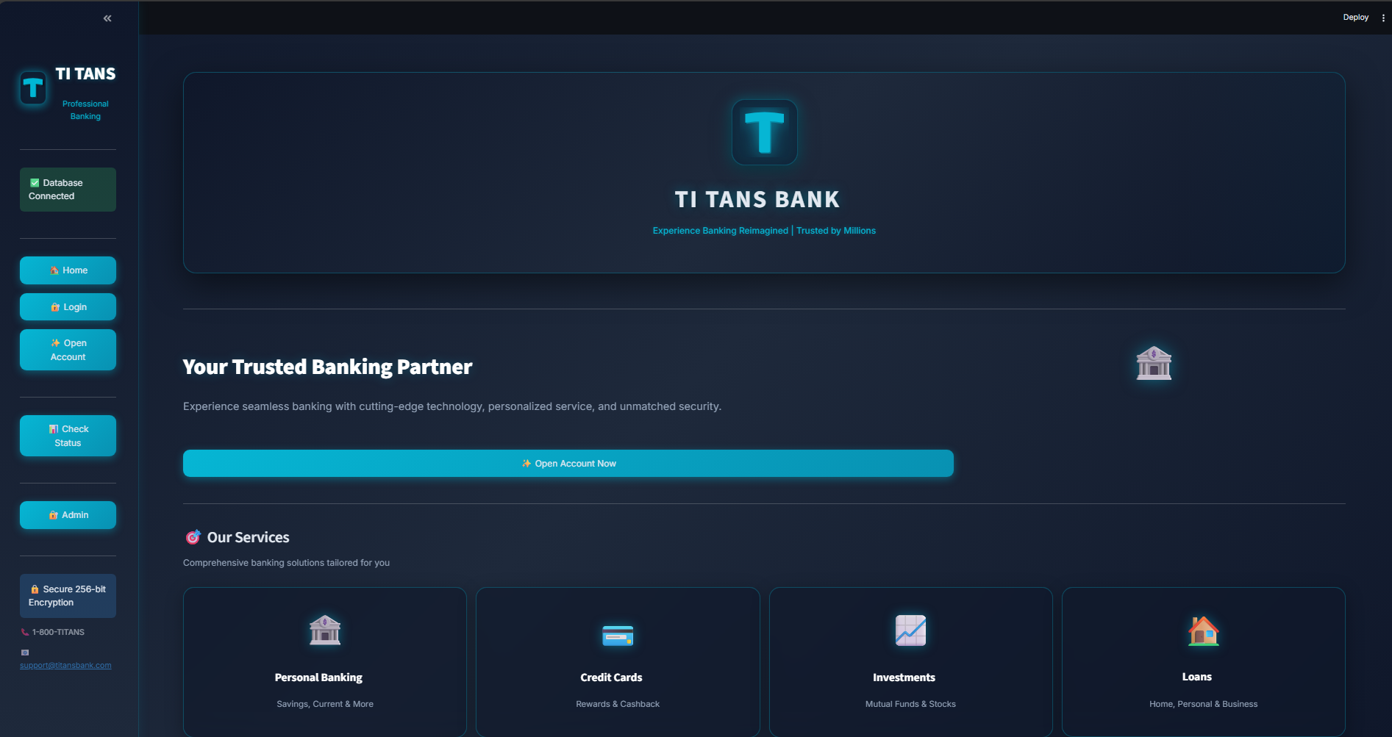

Step 2: Open Account Selection on Screen
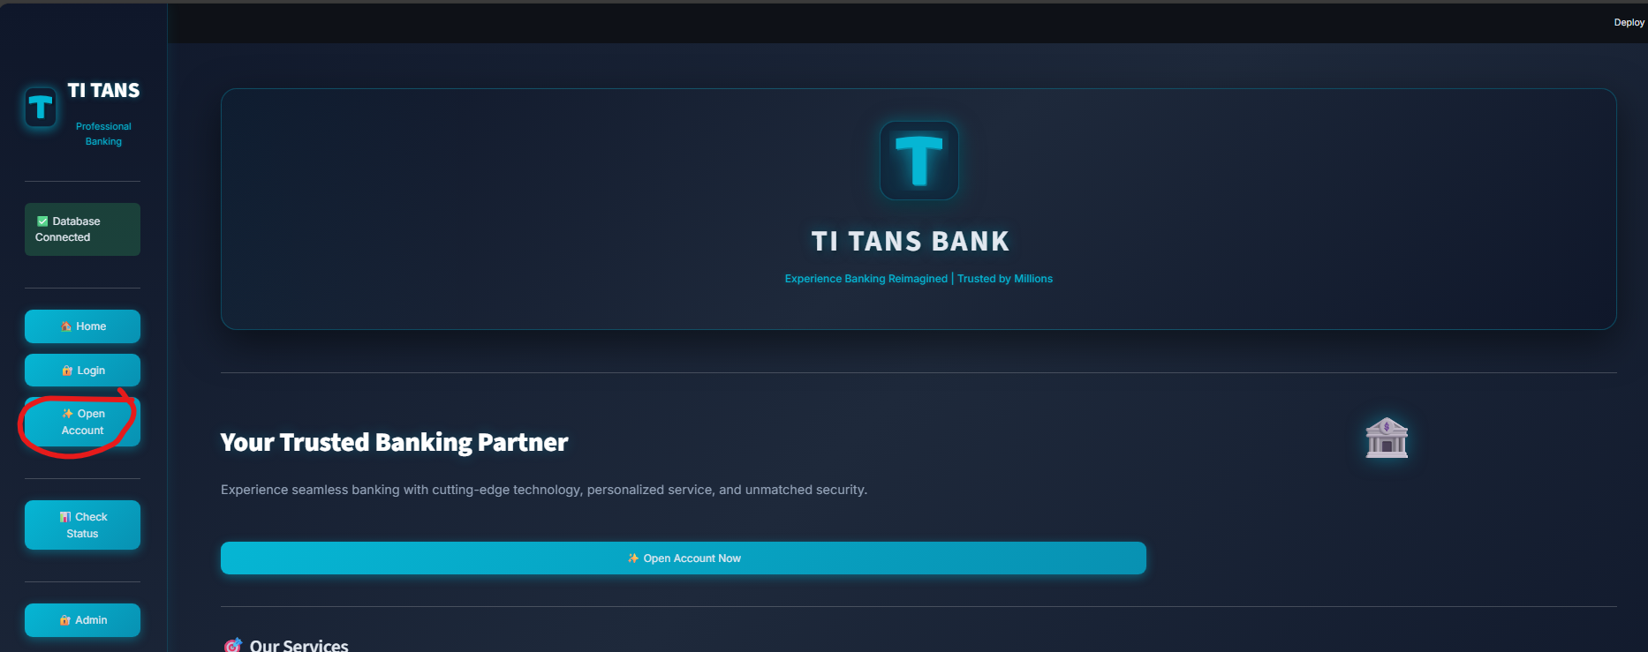
Step 3: New Account Registration – Details Entry Form
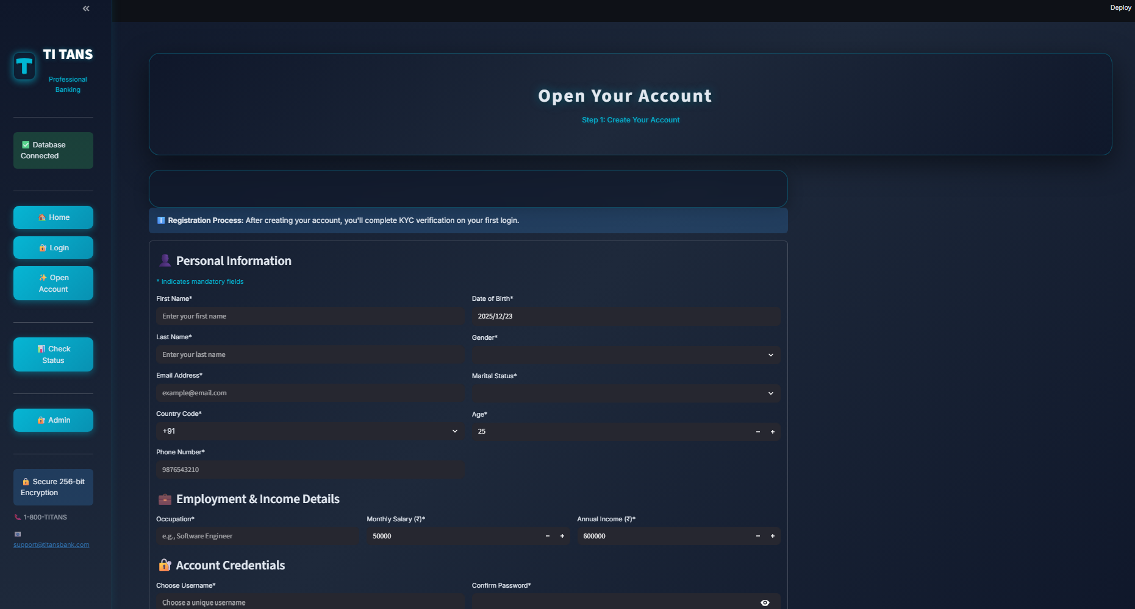

Step 4: Personal Information Section
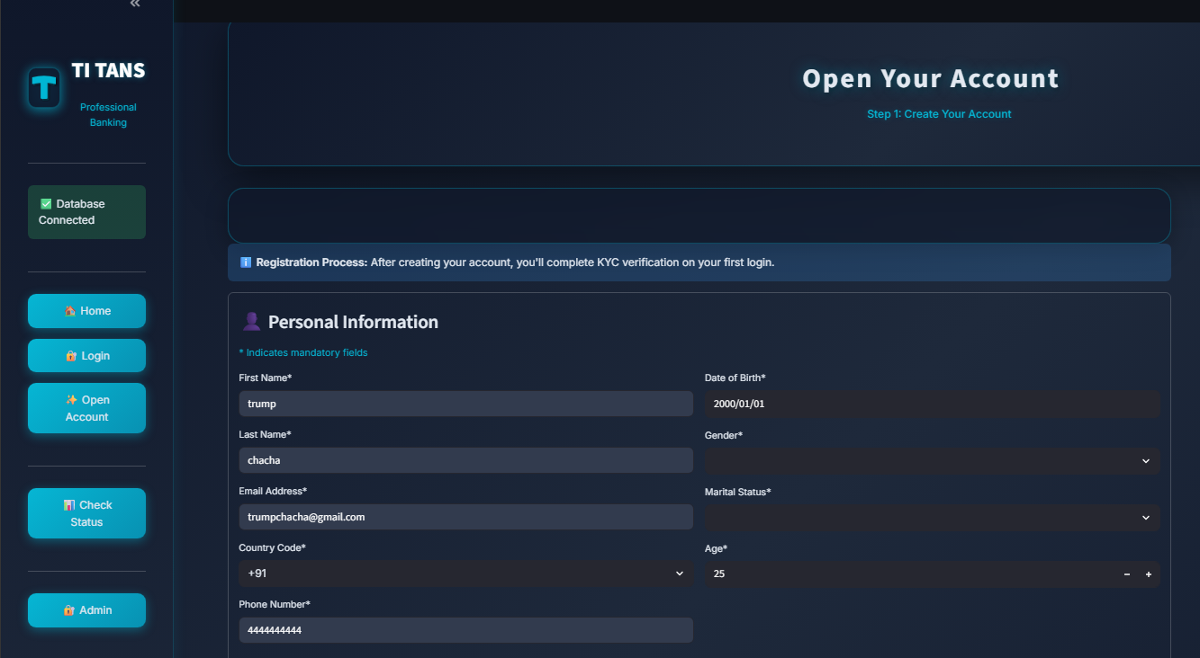
Step 5: Employment and Income Details Section
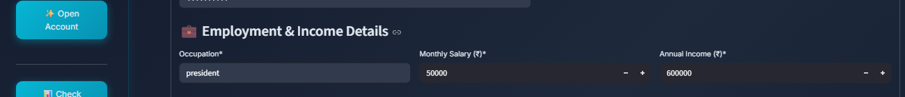
Step 6: Username and Password Creation Screen
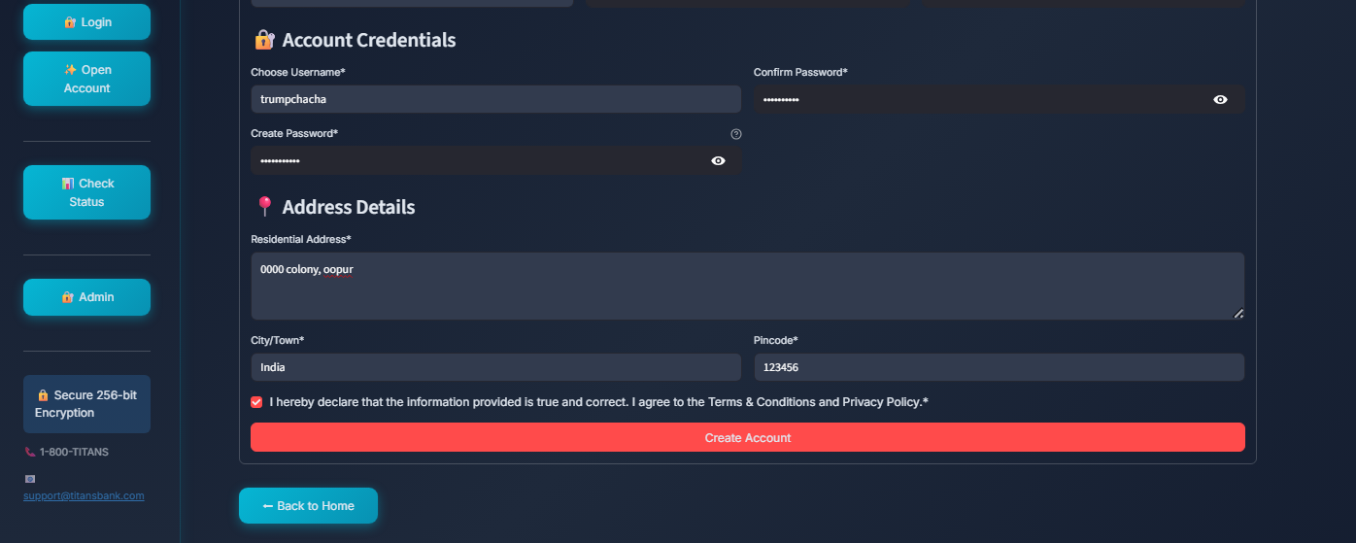

Step 7: Address Details and Declaration Checkbox


Step 8: Login Page – Enter Username and Password
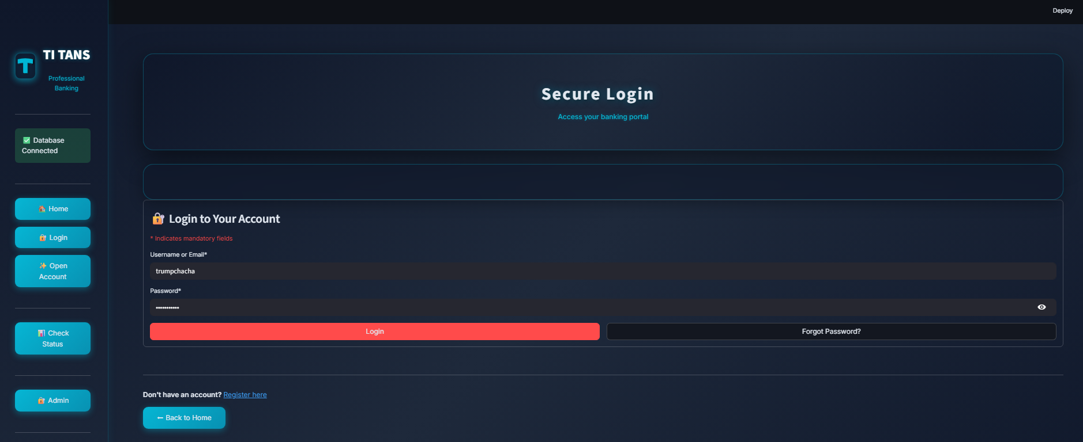

Step 9: Complete KYC Page
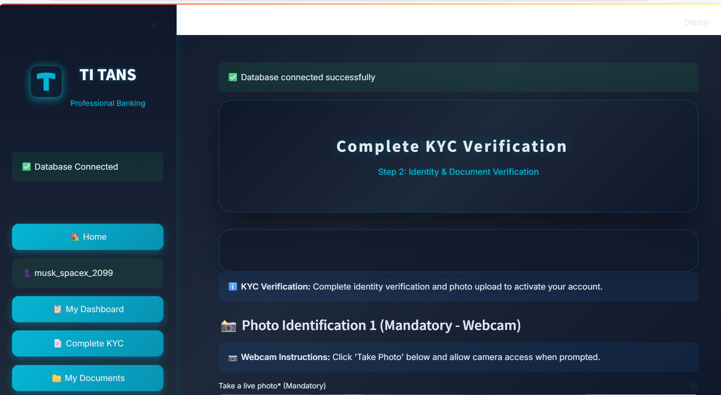

Step 10: Browser Camera Permission Prompt
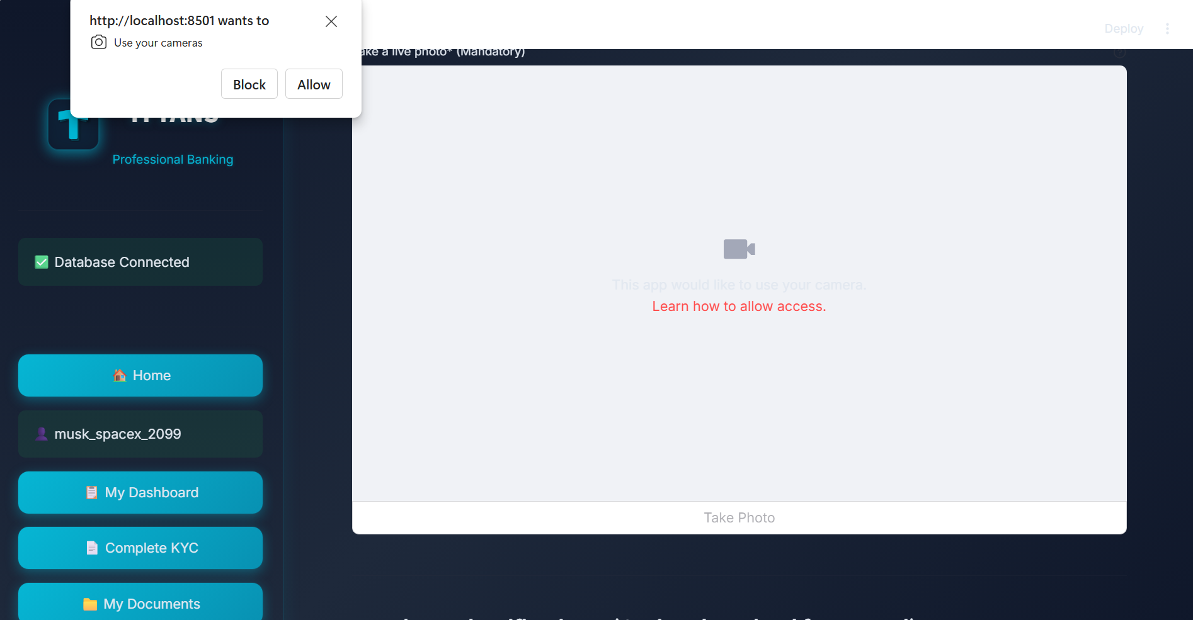
Step 11: Live Webcam Photo Capture and should pass AI checks
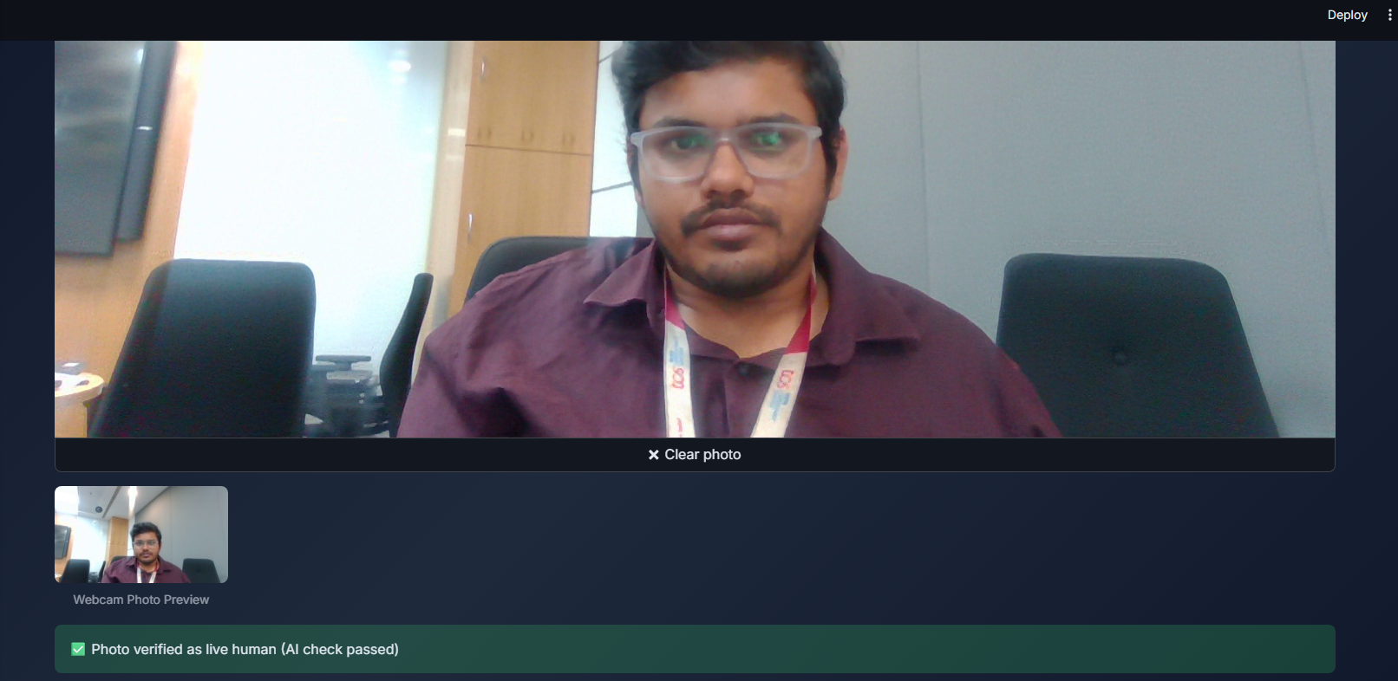
Step 12: Upload Photo from Local Option
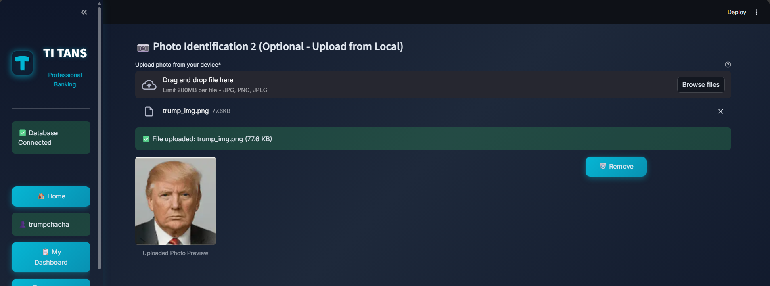

Step 13: Identity Document Selection and Submission
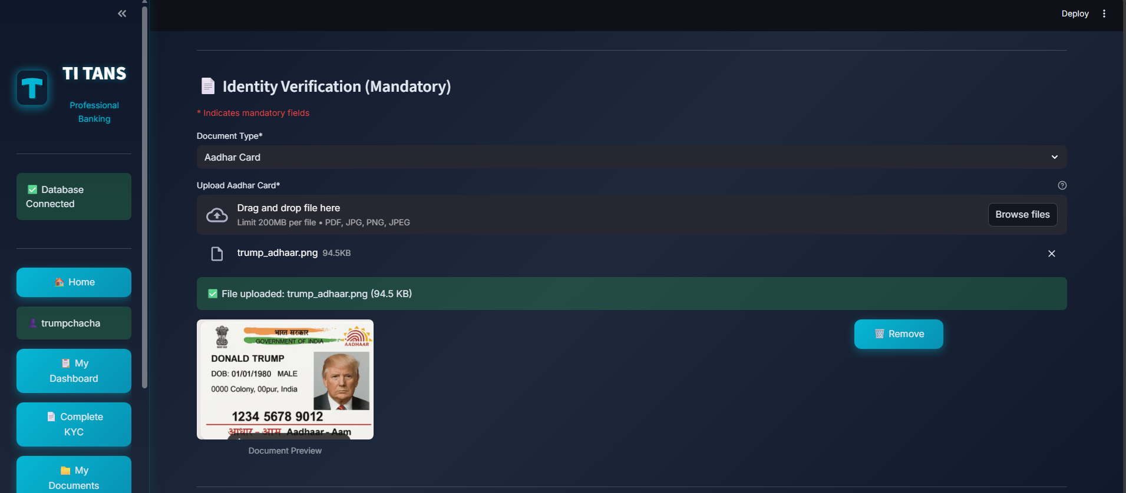

Step 14: Live Video Verification
- Click on Start and Wait for Camera
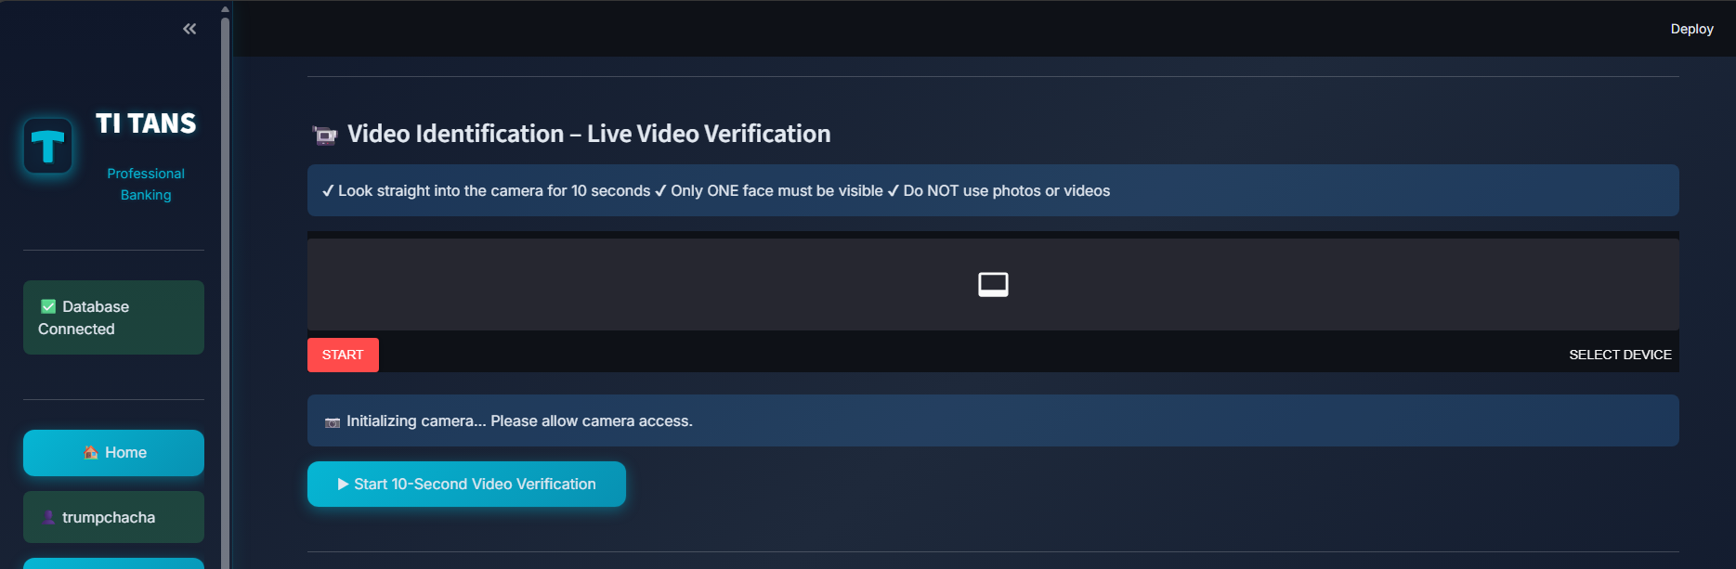
- Make sure only your face in the camera and click on Start 10 second video
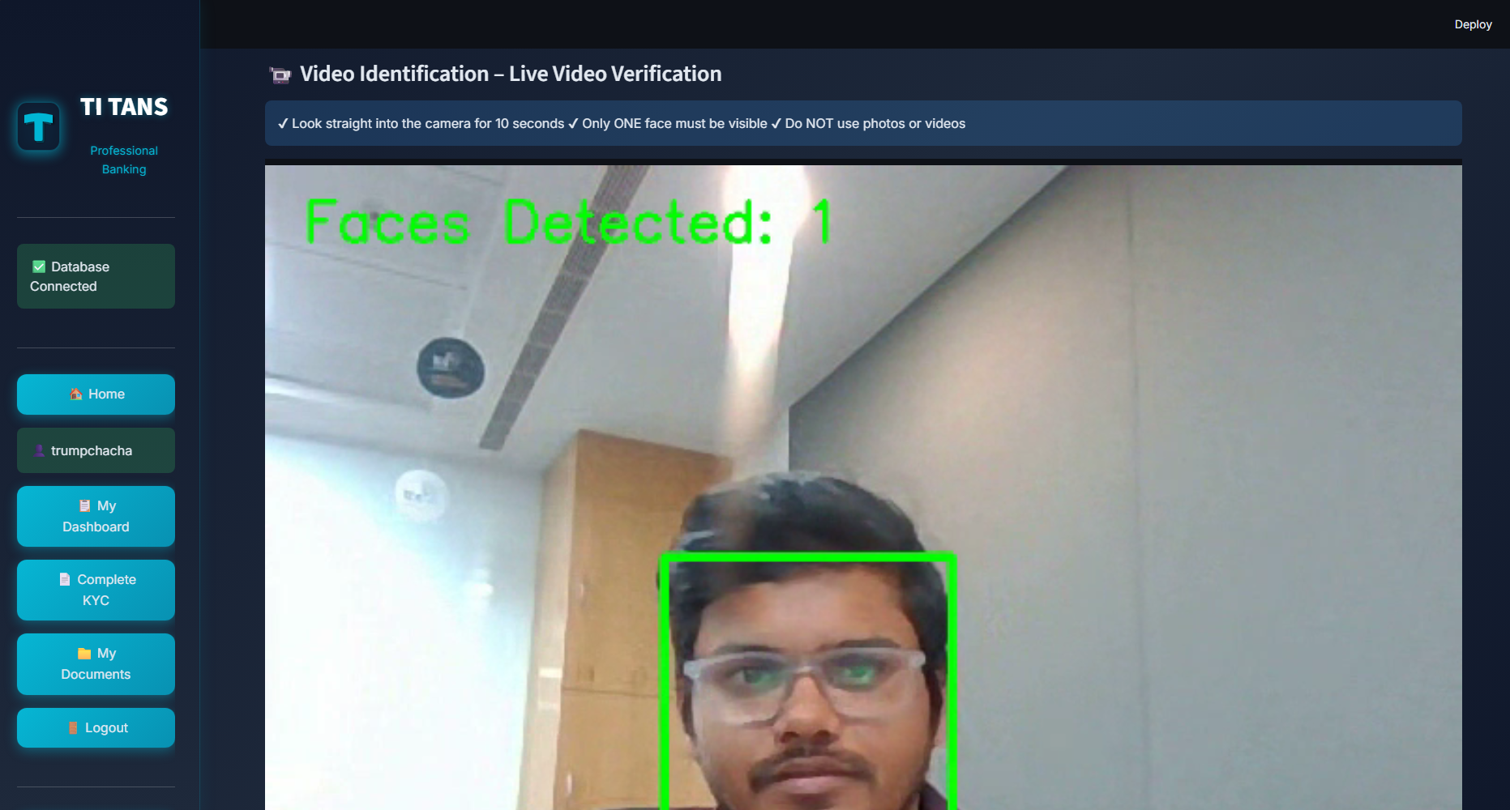
- Look in to the camera for 10 seconds
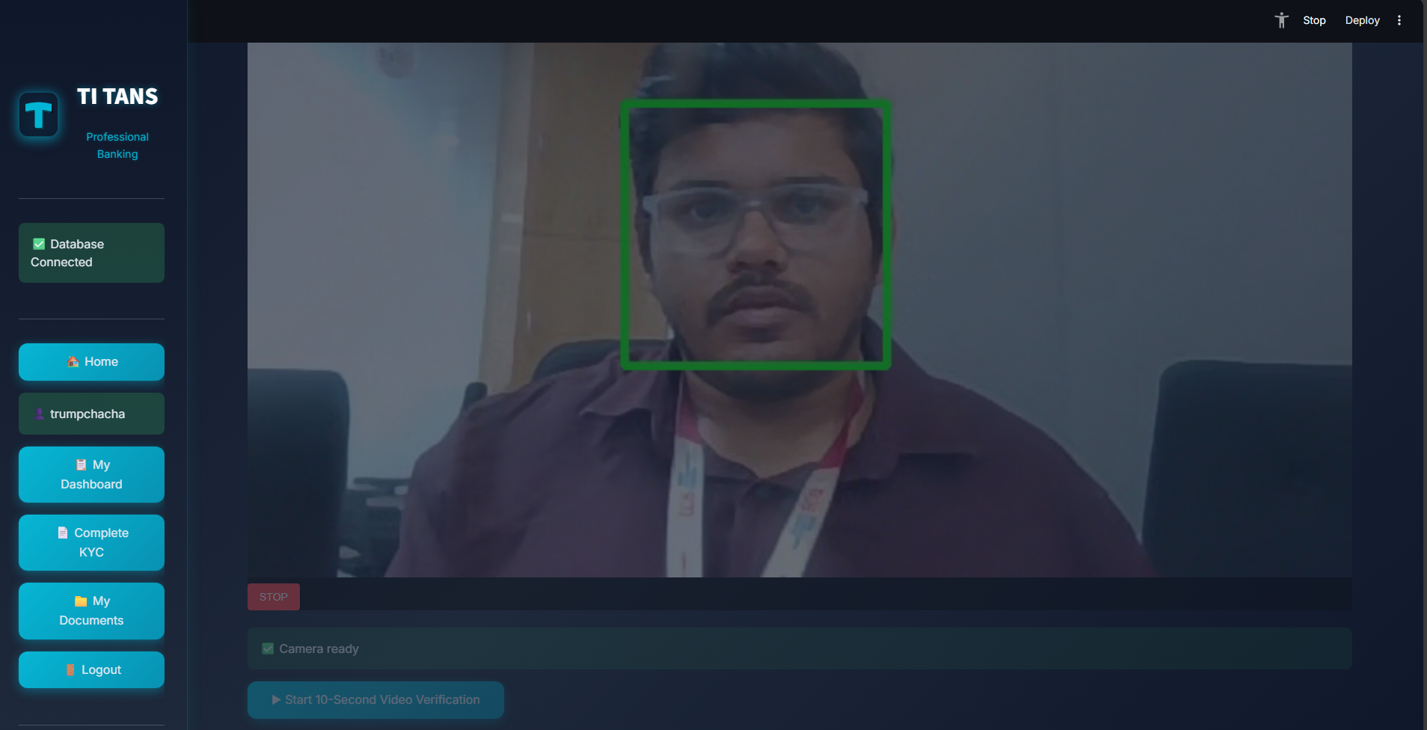
- Click on stop after 10 seconds
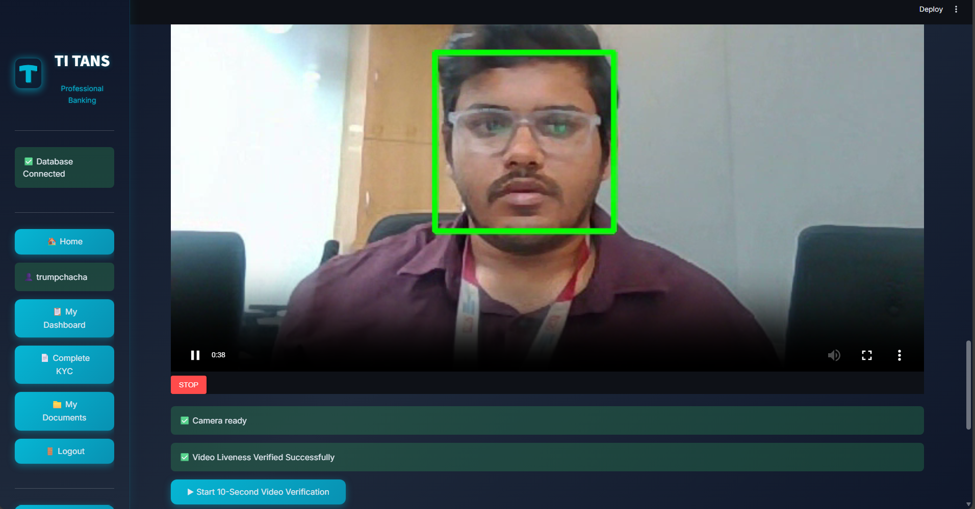

Step 15: Add Additional Information (optional) and tick check box and click submit
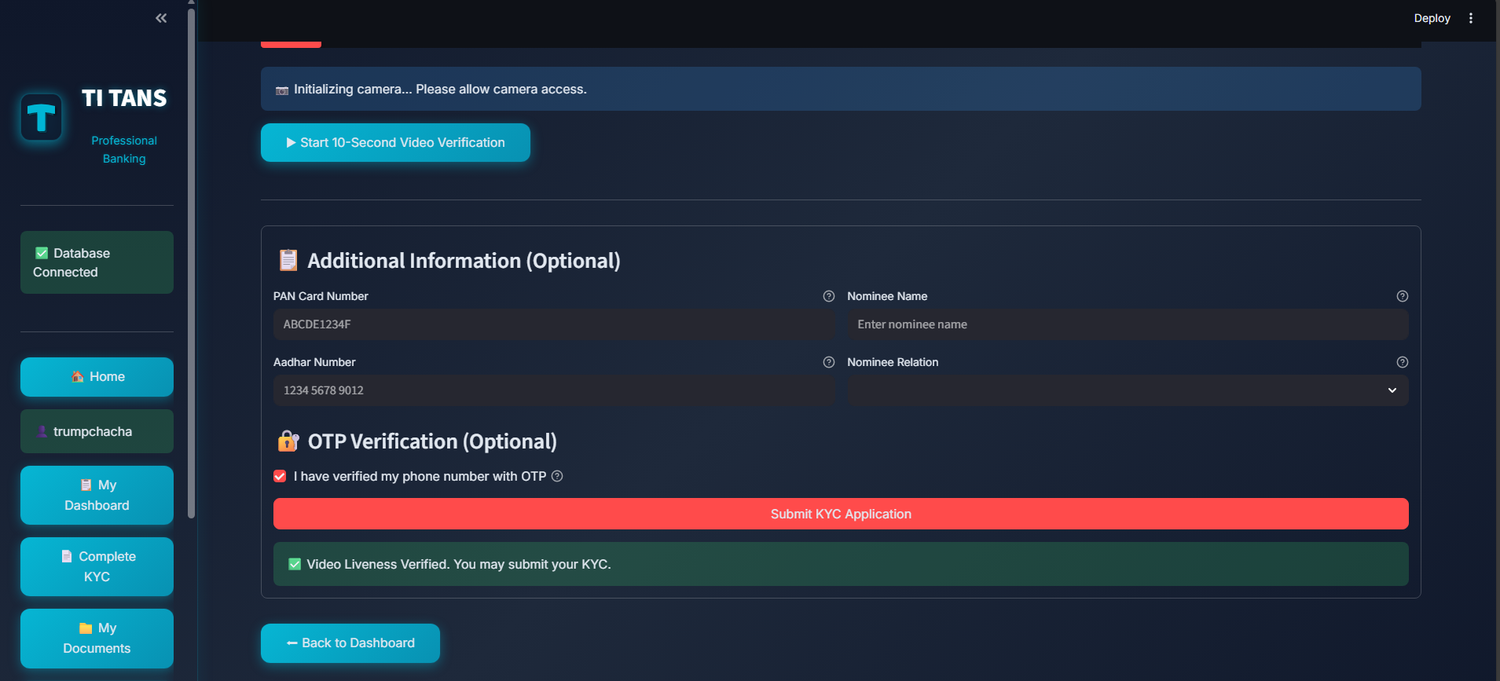
Step 16: User Dashboard After Successful Login and KYC
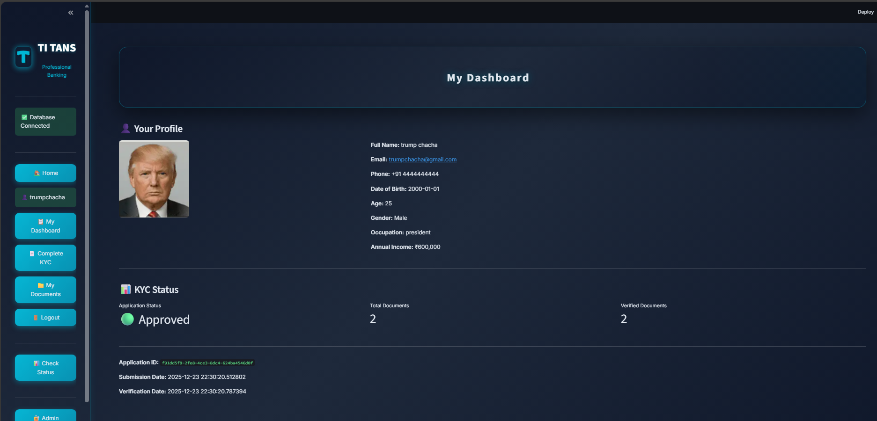

Step 17: User can check KYC status at Check Status
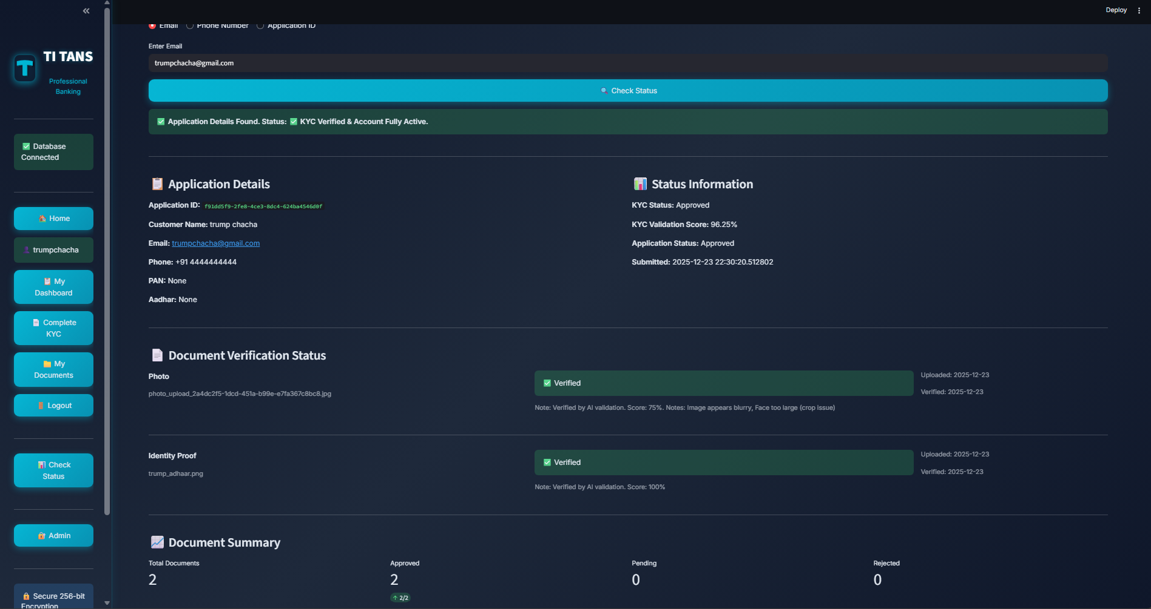

Step18: Check rejection reasons and reupload require docs. For any issues check with Customer Support
- Integrated support channels: phone (1-800-TITANS), email (support@titansbank.com), live chat
- 24/7 availability with ticket tracking

Security Notice
All customer information must be handled securely. Do not share login credentials or sensitive documents with unauthorized individuals.

